Stakeholder analysis and communication
Simply put, a stakeholder is anyone who is either interested or is likely to be affected by your (impact) project. This could be whilst the project is ongoing and / or after it has completed. Anyone with a stake in your project is a stakeholder. Stakeholders can be internal and external. For the public health domain external stakeholders can be found among government, public knowledge and healthcare institutions, insurers, companies and sector- and patient organizations. If the stakeholder is an organization, try to ensure you identify the right person to communicate with (is it a decision maker, influencer or budget holder?). Which professionals e.g. policy makers, healthcare professionals, citizens or patients have an important interest in the execution of your impact project? Internal stakeholders can be colleagues, students, managers or heads of divisions/ departments or faculties.  There are three steps to follow in making a stakeholder analysis. This is best done by a small group (during e.g. a brainstorm session) of the core project team, led by you:  - start making a long list of possible stakeholders  - identify who your most important stakeholders are and work out their power and interest, so that you know who you should focus on and how (with use of Figure 1)  - develop a good understanding of these stakeholders, so that you know which ways are best to communicate with them or engage them in your project to win their support. The only way to figure out what their interests are is to talk to them (see Checklist network meetings and the table below) | 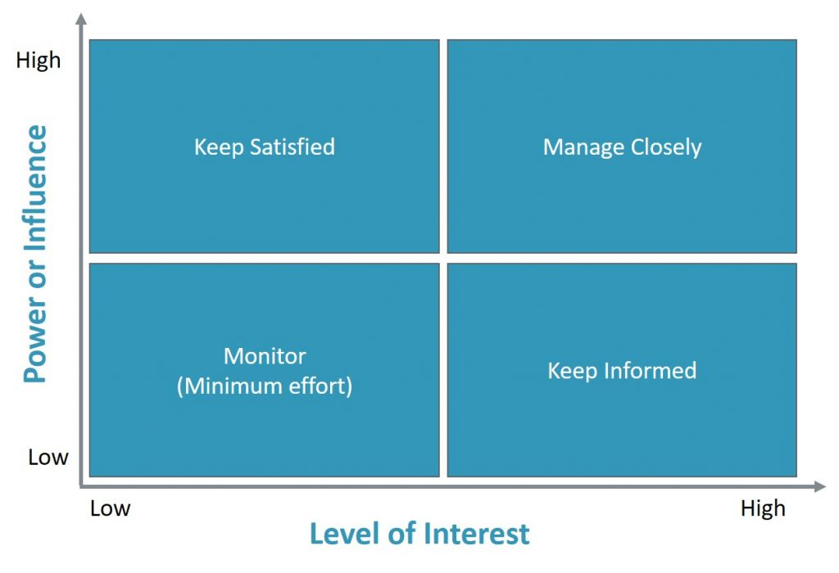  Figure 1: Power/interest grid for stakeholder prioritization

The position that you allocate to a stakeholder on the grid shows the different approaches you need to take:
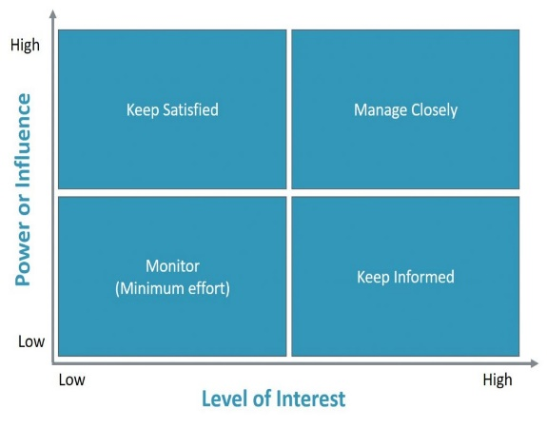
- High power, highly interested people (Manage Closely): these stakeholders are likely to be decision makers and have the biggest impact on the project success. They are key players and you need to keep these stakeholders close, you have to manage their expectations.
- High power, less interested people (Keep Satisfied): put enough work in with these people to keep them satisfied. Keep them in the loop, you might push them to the right side. Even though they may not be so much interested in the outcome, they yield power. These type of stakeholders should be dealt with cautiously because they could use their power in a negative way if they become unsatisfied.
- Low power, highly interested people (Keep Informed): adequately inform these people, and talk to them to ensure that no major issues are arising. People in this category can often be very helpful with the details of your project and they can be an ambassador or supporter of your project.
- Low power, less interested people (Monitor): monitor this group of people and keep them up to date. This group has a low priority.

Use this table to take the third step of the stakeholder analysis:
Name stakeholder: people, groups and organizations | Role of the stakeholder:  decision maker, influencer or budget holder | Position and importance stakeholder:  key players, keep informed, keep satisfied, low priority | What are the interests of the stakeholder? What is important for them? | What are possible barriers? How could they block your efforts? | Most effective ways to engage or inform them? E.g. one-on-one, newsletter, mails, meetings, collaborations, two-way dialogue? * | Frequency?  Weekly, monthly, quarterly? | What angle or content will you use to keep the stakeholder engaged or informed?

*A Guide to Stakeholder Engagement for Healthier Communities | News and Analysis | Healthy Business Coalition (bsr.org) and have a look at the Stakeholders engagement continuum
APH-IXA 01-09-2023

