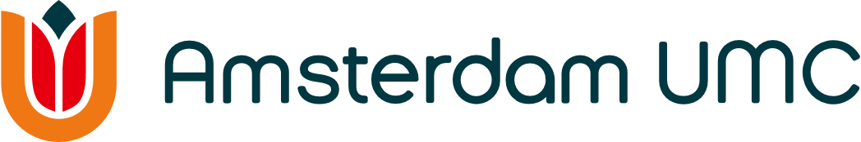
Amsterdam Cardiovascular Sciences
Application form Work Visit Grant 2026

Please send this form to acs@amsterdamumc.nl

Deadline first application round: Monday August 24th 2026 at 11:00 AM

Personal details
- Personal details
- Name (initials and surname) and title
- Function
- Department
- Email address

- Details of your supervisor and promotor (if applicable)
- Name (initials and surname) and title
- Function
- Department
- Email address

Description of your work visit
Expected start date:

- Details of the research institute you would like to visit
- Name of the institute
- Address
- Name of your supervisor in the host institute
- Email address

- What are your intended learning objectives?
Max. 500 words
- Research plan for the work visit
- Describe why this research cannot be performed in Amsterdam UMC
- Describe your time plan and make a budget for your work visit

- What are the benefits for ACS?
Max. 300 words
- Describe how this work visit will benefit your own research and how ACS in general will benefit

Additional information
- Explanation of how to travel as sustainably as possible (e.g. train) to the destination.
When the location can only be reached by plane, a clear argument must be made as to why it is necessary for the project to travel to this host institute.
Additional information
- Enclose your CV to this application

Signatures
- Signature of applicant

- Signature of promotor or (PhD) supervisor (if applicable)

- Signature of head of the department

