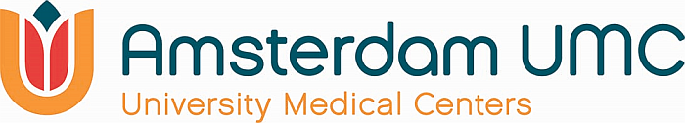

Amsterdam Reproduction & Development

AR&D Travel Grant 2024-2025 application form

1. Information of applicant and affiliations

Details applicant
Title(s): Klik of tik om tekst in te voeren.
Given name: Klik of tik om tekst in te voeren.
Initial(s): Klik of tik om tekst in te voeren.
Surname: Klik of tik om tekst in te voeren.
Department: Klik of tik om tekst in te voeren.
Contractually appointed at Amsterdam UMC location/VU/UvA: Klik of tik om tekst in te voeren.
E-mail: Klik of tik om tekst in te voeren.
Birth date: Klik of tik om tekst in te voeren.
(Expected) doctorate (dd/mm/yy): Klik of tik om tekst in te voeren.
PURE profile url (showing affiliation to AR&D): Klik of tik om tekst in te voeren.
Supervising AR&D PI (promotor and/or co-promotor)
Title(s), initial(s), surname: Klik of tik om tekst in te voeren.
Department: Klik of tik om tekst in te voeren.
Contractually appointed at Amsterdam UMC location/VU/UvA: Klik of tik om tekst in te voeren.
E-mail: Klik of tik om tekst in te voeren.
PURE profile url (showing affiliation to AR&D): Klik of tik om tekst in te voeren.

Bio-sketch of applicant
Please provide a bio-sketch of maximum half A4 (font size 11). A typical bio-sketch should include a narrative description about the applicant written in third person, however information may be provided in lists or schemes if more appropriate.
- Name, position, title, education/ training
- AR&D research subject (PhD/postdoc)
- Grants and prizes
- Core skills and competences (relevant to this proposal)
- Max. 3 of relevant key peer-reviewed publications

Klik of tik om tekst in te voeren.

2. Travel plans

Type of visit
☐ Symposium/conference → Please complete the information under A.
☐ Oral presentation
☐ Poster presentation
☐ Working visit international lab/department → Please complete the information under B.

- Information about the symposium or conference
Name: Klik of tik om tekst in te voeren.
Country, city: Klik of tik om tekst in te voeren.
Time period: Klik of tik om tekst in te voeren.
Description of audience/participants: Klik of tik om tekst in te voeren.
Website: Klik of tik om tekst in te voeren.

Explanation of how to travel as sustainably as possible (e.g. bike/train) to the conference/symposium
When the conference/symposium can only be reached by plane, a clear argument must be made as to why it is necessary to attend this conference.
(see the sustainable business travel policy from Amsterdam UMC (only in Dutch))
Klik of tik om tekst in te voeren.

Abstract
☐ to be submitted
☐ submitted
☐ accepted for posterpresentation
☐ accepted for oral presentation

Please provide abstract: Klik of tik om tekst in te voeren.

- Information about the working visit
Institute, department: Klik of tik om tekst in te voeren.
Country, city: Klik of tik om tekst in te voeren.
Time period: Klik of tik om tekst in te voeren.
Your contact person (Title, name): Klik of tik om tekst in te voeren.
Website of department or contact person: Klik of tik om tekst in te voeren.

Aim of the working visit (max. 50 words)
Klik of tik om tekst in te voeren.

Program of working visit (please include a schedule per week)
Klik of tik om tekst in te voeren.

Motivation why this working visit is necessary for the research (max. 300 words)
Klik of tik om tekst in te voeren.

Explanation of how to travel as sustainably as possible (e.g. bike/train) to the working visit
When the working visit can only be reached by plane, a clear argument must be made as to why it is necessary to attend this conference.
(see the sustainable business travel policy from Amsterdam UMC (only in Dutch))
Klik of tik om tekst in te voeren.

Please include a letter of support from the contact person of the relevant institution as an attachment to this application form.

3. Budget plan
For conference visits a maximum of €1000.- can be requested. For work visits a maximum of €2500.- can be requested.
What are the costs that will be made?
Estimated total costs: Klik of tik om tekst in te voeren.
Travel costs: Klik of tik om tekst in te voeren.
Accommodation costs: Klik of tik om tekst in te voeren.
Conference registration fees: Klik of tik om tekst in te voeren.
Other, please specify: Klik of tik om tekst in te voeren.
TOTAL requested amount: Klik of tik om tekst in te voeren.

In case of a higher budget than covered by the AR&D Travel Grant. How are the additional costs financed?
Klik of tik om tekst in te voeren.

Please send this form as a PDF file to ARandD@amsteramumc.nl before 31 March 2024 12:00h pm.
Note: In case of a working visit, include a letter of support from the contact person of the relevant institution as an attachment to this application form.
Eligibility requirements
- Each applicant can submit only one proposal for AR&D Travel Grant 2024-2025. Applicants who received an AR&D Travel Grant in 2023 may not submit a new application this year.
- The applicant and the supervisor must be affiliated with AR&D (as shown by PURE profile). The applicant should be employed at Amsterdam UMC or at affiliated universities (UvA or VU). Junior researchers, research nurses, PhD students and postdocs (who obtained their PhD no longer than 3 years ago at the time of grant deadline) are eligible to apply. Bachelor students, master students or student assistants are not eligible to apply.
- When visiting a conference or working visit abroad, a clear travel plan should be added to ensure the most sustainable travel possible (e.g. by train). If the conference or working visit can only be reached by plane, a clear argument must be made as to why it is necessary to attend this conference or working visit.
- Working visits require a letter of support from the contact person of the relevant institution.
- This grant can only be used for this proposed conference or working visit.
- Only visits between 1 May 2024 and 1 May 2025 are eligible.
- This grant funds conference visits (maximum €1000.-) or working visits (maximum €2500.-) in the field of human reproduction and development (see mission AR&D website). It includes, but is not restricted to: fundamental, translational, clinical science and public health research.
- Proposals for working visits should have a clear research question or objective. Proposals for conference visits should include an accepted (preferably oral/poster presentation), submitted or to-be submitted abstract.
- Proposals should be written in concise English understandable to a researcher in a neighboring science field.
- The applicant has to be available to attend the award ceremony on Thursday 23rd of May 2024 or send someone in their place.
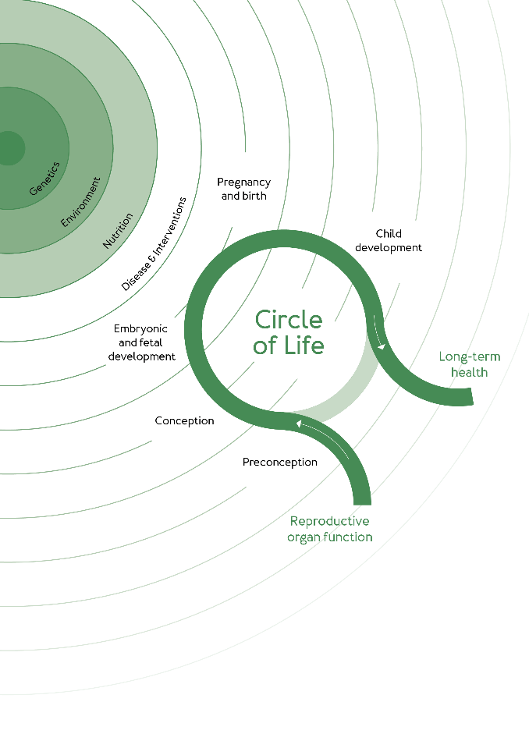
- All awarded proposals are obliged to send a final report on the visit within 3 months after the visit to AR&D office for approval.

