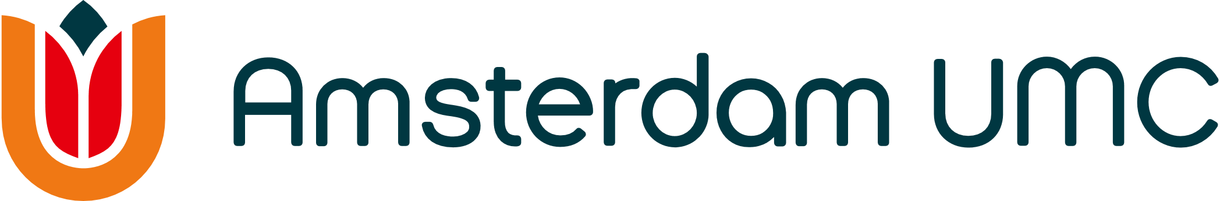
Amsterdam Cardiovascular Sciences
Application form Out of the Box Grant 2024

Please send this form before September 5th 2024 at 11:00 AM to acs@amsterdamumc.nl

1. PROJECT TITLE
Title:

2. CONTACT INFORMATION OF THE TWO MAIN APPLICANTS

Name:
Email address:
Department:
Amsterdam UMC location:

Name:
Email address:
Department:
Amsterdam UMC location

3. PARTICIPATING INVESTIGATORS

Name | Position | Department – location AMC/VUmc | Hours/week

4. RESEARCH PERIOD & BUDGET (max €50.000)
Proposed start date:
Proposed end date:
Budget requested at department [please fill in name and cost center of department]:
Budget requested department [please fill in name and cost center of department]:

For VUmc departments only
Distribution of the budget over years:
2024:
2025:
2026:
5. Summary (MAX 100 words)
Please note that this summary will be used for communication purposes
6. PROJECT (MAX 2 PAGES)
Health care problem & background

Main objective

Brief research plan (highlight excellence/innovative/translational aspects)

Embedding and contribution to Amsterdam UMC cardiovascular and translational research (clinical-preclinical collaboration)

Future grant application and studies
Describe which grant you intend to submit in the future and how this future application(s) will benefit from the proposed research when granted.

7. CURRICULUM VITAE OF THE APPLICANTS
Include the CV of minimum 2 applicants and maximum 4 applicants (max 1 page per applicant)

CVs should include the following:

Positions and honors

Peer-reviewed publications of the last 5 years

Research support over the last 5 years

8. REFERENCES

